**--------------------------------------------------------------------------------------------------------------------------**

PROJECT REPORT ON

**CRYPTOCURRENCY TRADING PORTAL**

Submitted By

**Karan Jadhav**

**--------------------------------------------------------------------------------------------------------------------------**

**INDEX**

1.Introduction

* Project Overview
* Objectives

2. Technology Stack

* + HTML
  + CSS
  + JavaScript
  + Bootstrap

3. Features

* + Technologies Used
  + Highlights

4. Output/Screenshots

5. Conclusion

**Introduction:**

**Project Overview**

The Cryptocurrency Trading Portal is a comprehensive web application designed to facilitate the buying, selling, and trading of various cryptocurrencies. The portal provides users with a secure and efficient platform to manage their digital assets, view real-time market data, and perform transactions seamlessly**.**

**Objectives**

* To create a user-friendly interface for cryptocurrency trading.
* To ensure secure transactions and storage of cryptocurrencies.
* To provide real-time updates on market prices andtrends**.**

**Technology Stack:**

**Introduction to HTML**

Web publication deals with the study of HTML for creating web pages. A website is a collection of web pages, also referred to as documents. These can be viewed using browsers like Internet Explorer or Netscape Navigator.

Each of the things that are to be displayed on Web page need the help of TAG’s & in some cases attributes for each TAG. HTML stands for Hypertext Markup Language.

HTML specifically for use on the World Wide Web. Hypertext has the ability to be connected to the other text and it can be navigated by a system of links which can be non-sequential in order.

Features of HTML**:**

1. Subset of SGML (Standard Generalized Markup Language).
2. Interpreter-based language.
3. Formatted language.
4. Completely static.
5. Platform-independent.

**Introduction to CSS**

CSS (Cascading Style Sheets) is a stylesheet language used to describe the presentation of a document written in HTML or XML. It controls layout, appearance, and formatting of web pages, allowing developers to separate content from design. CSS enables precise control over elements like fonts, colours, spacing, and positioning.

Features of CSS:

1. Applied internally within an HTML document, externally through separate CSS files, or inline within individual HTML.
2. Provides extensive capabilities for styling and formatting web pages.
3. Enhances the visual appeal and user-friendliness of websites.

**Introduction to Bootstrap**

Bootstrap is a popular front-end framework for developing responsive and mobile-first web pages. It provides a collection of reusable CSS and JavaScript components, such as navigation bars, forms, buttons, and modals. Bootstrap enables quick creation of visually appealing and user-friendly interfaces with minimal custom CSS.

Features of Bootstrap:

1. Utilizes a grid system for flexible and adaptive layouts.
2. Provides built-in support for various HTML elements and utility classes for common styling needs.
3. Ensures consistent design across web applications.

**Introduction to JavaScript**

JavaScript is a versatile programming language used for creating dynamic and interactive web content. It is essential for enhancing user experience on websites by enabling real-time updates and interactions without reloading pages.

Features of JavaScript:

1. Manipulates the Document Object Model (DOM) for real-time updates.
2. Handles tasks like form validation, dynamic content updates, and user event handling.
3. Supports libraries and frameworks like jQuery, React, Angular, and Vue.js.

**Key Features:**

* Responsive Design: Utilizes HTML, CSS, and Bootstrap to ensure the application is fully responsive and accessible across various devices and screen sizes.
* Interactive User Interface: JavaScript and jQuery are used to create dynamic elements and enhance user interaction.
* Trading Management: Allows users to buy and trade cryptocurrencies with a user-friendly interface.
* Wallet Integration: Provides users with separate wallets for storing different cryptocurrencies.
* Transaction History: Displays a detailed transaction history for users to track their trades and purchases.

**Technologies Used:**

* HTML: Structures the web pages and forms, providing the backbone of the application.
* CSS and Bootstrap: Styles the application and ensures a consistent and visually appealing layout across different devices.
* JavaScript and jQuery: Add interactivity and handle client-side logic, such as form validation, dynamic content updates.
* LocalStorage: Stores user information and trading data locally for a seamless experience.

**Highlights:**

* Responsive Layout: Ensures the application looks and works great on both desktop and mobile devices.
* User-Friendly Forms: Simplifies the trading process with clear and concise input fields and real-time validation feedback.
* Interactive Features: Enhances user experience with dynamic elements like real-time trading charts and pop-up notifications.
* Scalability: Designed with scalability in mind, allowing for easy addition of new features and expansion of services.

**Outputs/Screenshots:**

**Home Screen:**

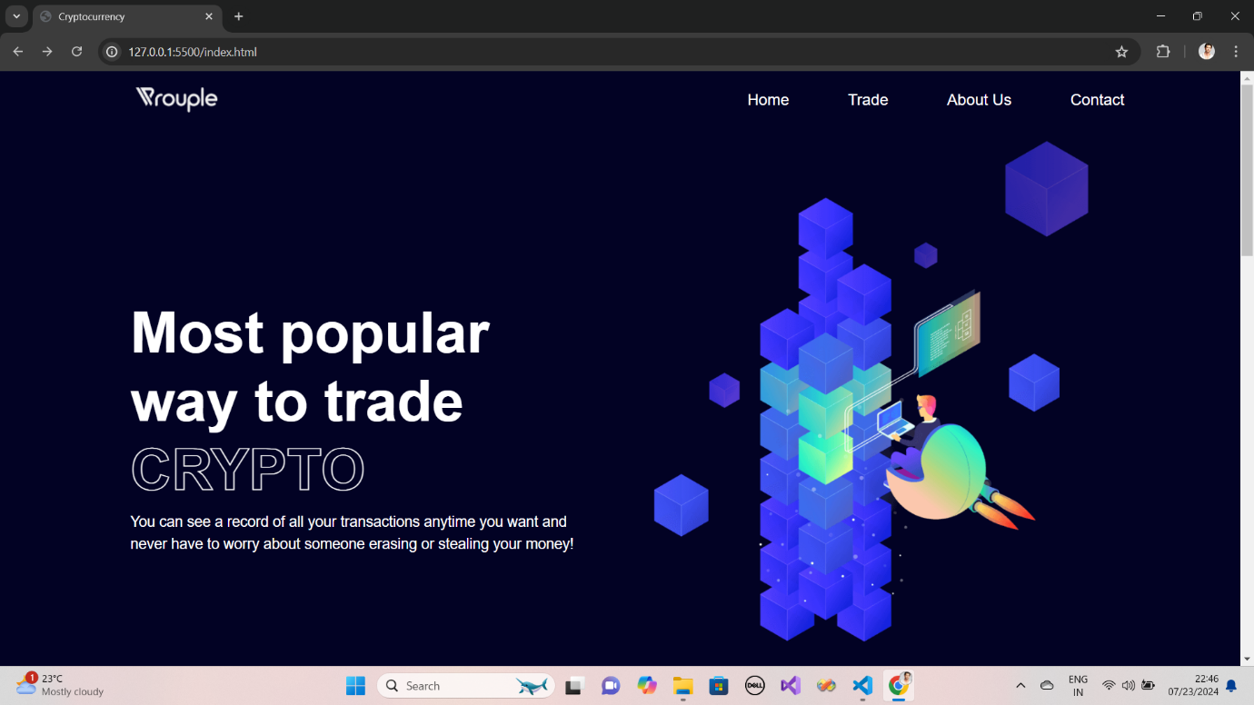

**About Us:**

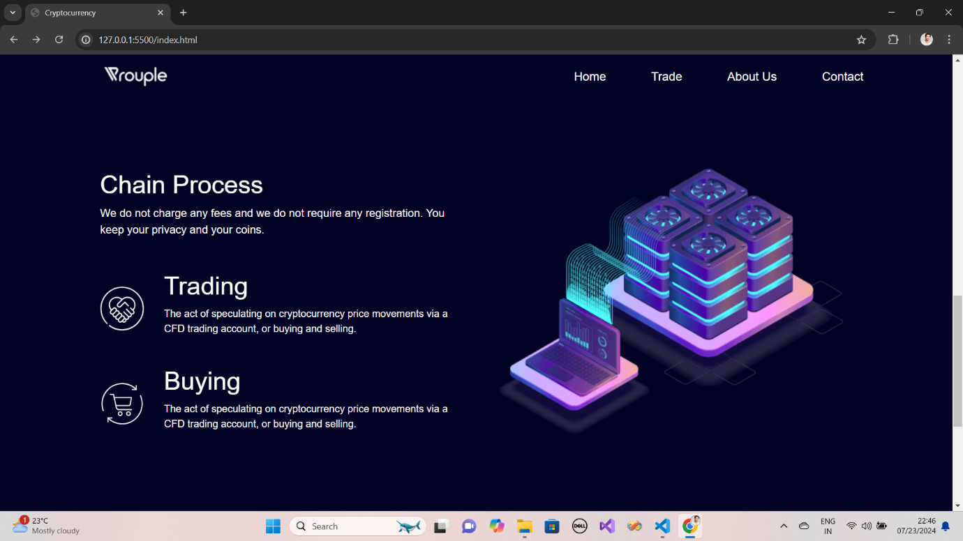

**Contact Us:**

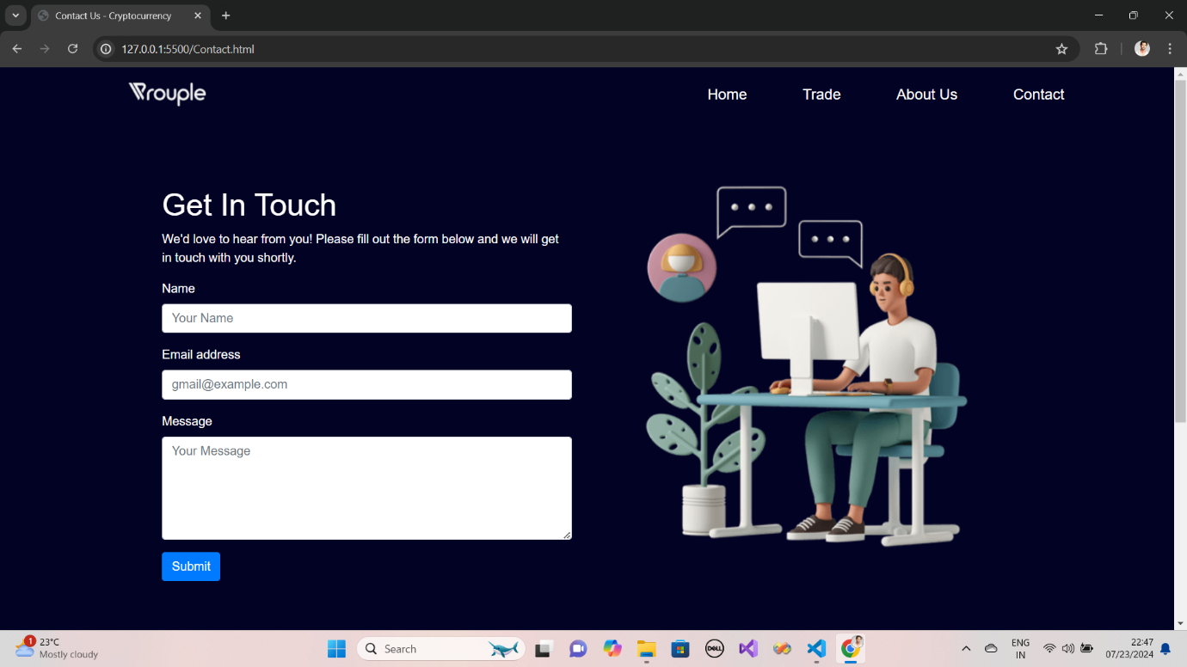

**Buy & Trade:**

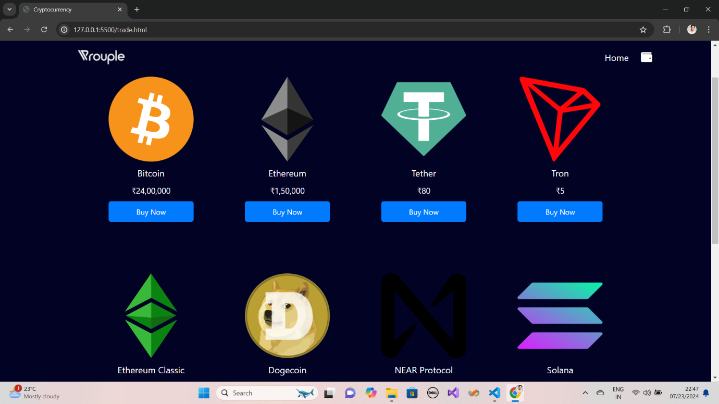

**Personal Wallet:**

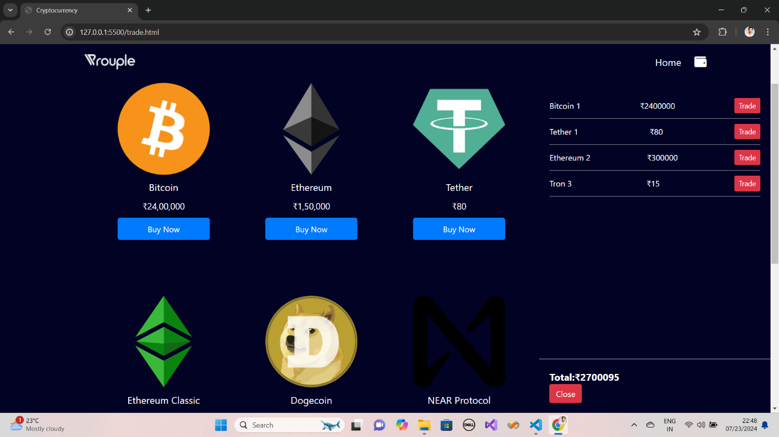

**Trade:**

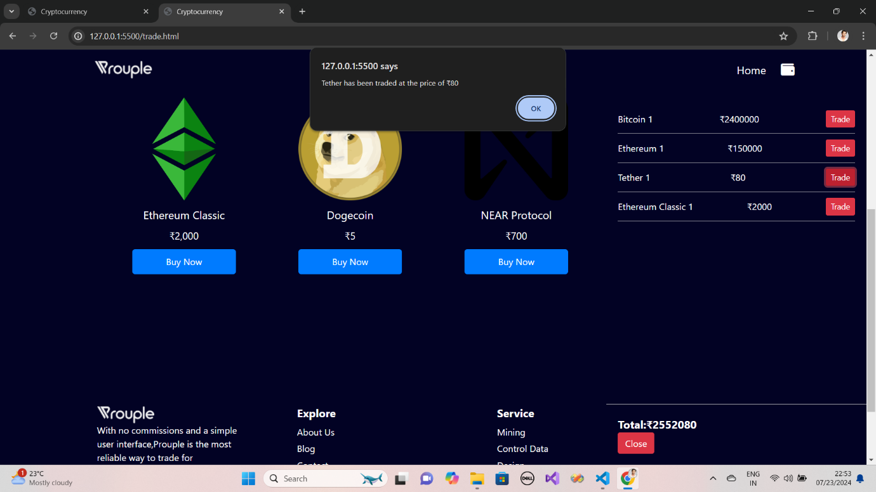

**Conclusion:**

* The Cryptocurrency Trading Portal provides a valuable tool for users to manage and trade digital assets securely.
* The platform’s real-time data integration and responsive design contribute to an efficient and engaging user experience.
* Provided seamless buying, selling, and trading functionalities for cryptocurrencies.
* Enabled effective wallet management for users, with support for multiple currencies.
* Ensured the platform is accessible and responsive across various devices and screen sizes.